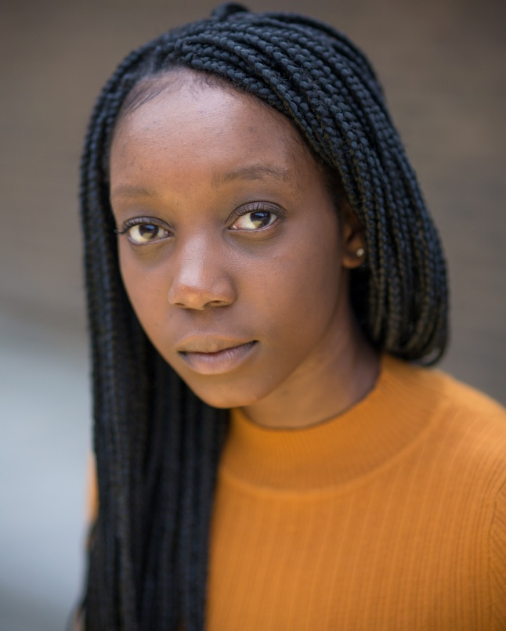**YVONNE GRUNDY**

30 Nottigham Close, Watford, WD25 7QT

Email:[Yvonnegrundyactor@outlook.com](mailto:Yvonnegrundyactor@outlook.com)

Contact : 07943560952

**Description:** 5ft5, Dark Brown Eyes, Black Hair

**Playing Range:** 16-25

**Accents:** RP, Standard American, Trinidad, Kentucky

**Equity Number: S00451904**

**Spotlight Pin:**  4613-7860-8456

**TRAINING**

Arts University Bournemouth, BA (Hons) Acting, 2015-2018

**SPECIAL SKILLS**

BASSC-Broadsword (pass), BASSC-Rapier & Dagger (pass), BASSC-Swashbuckling-Single Sword (pass), BASSC-Unarmed (pass), Forum Theatre, Clean driving licence, Singing, good movement skills, fluent Swahili speaker, Storytelling, cycling, Assistant Stage Manager(ASM)

**Experience whilst Training**

**Theatre**

‘Francine’ & ‘Lena’ Clybourne Park Sean Aita

‘Portia’ [Scene Study] Julius Caesar David O’shea

‘Audrey’ [Scene Study] Three Sisters Kenneth Robertson